NeighborLink – Powered by People, Driven by Kindness

Nasif Rahman (21-44993-2)
Thonmoy Banik (20-42701-1)
Khandkar Md Antik Mahmud (21-44425-1)

Table of Contents
Problem Domain 1
Background to the Problem 1
Root Cause and Importance of the Problem 2
Solution to the Problem …………………………………………………………………………………………………………….3
Existing Solutions and Limitations ………………………………………………………………………………………………4
Solution Description 5
Overview of the Proposed System …………………………………………………………………………………………….5
System Features ……………………………………………………………………………………………………………………….6
System Features 7
Functional Requirements ………………………………………………………………………………………………………….7
Non-Functional Requirements ………………………………………………………………………………………………….8
UML Diagrams 9
Social Impact ………………………………………………………………………………………………………………………………10
Development Plan with Project Schedule ………………………………………………………………………………….11
Marketing Plan ……………………………………………………………………………………………………………………………12
Cost & Profit Analysis…………………………………………………………………………………………………………………….13
References …………………………………………………………………………………………………………………………………….14

- PROBLEM DOMAIN
Background to the Problem
In modern urban and semi-urban communities, people often face difficulties in completing small yet essential daily tasks such as borrowing tools, grocery pickup, furniture moving, or seeking short-term assistance. This issue is especially common among elderly individuals, students living away from home, and busy professionals who lack immediate local support.
Although people live in close physical proximity, neighborhoods remain socially disconnected. Existing methods such as social media posts, phone calls, or asking acquaintances are often unreliable, time-consuming, and inefficient. As a result, many genuine needs remain unmet, leading to frustration, wasted time, and weakened community bonds.
This problem highlights the absence of a structured, trustworthy, and localized digital platform that can effectively connect people who need help with those willing to offer assistance within the same neighborhood

Root Cause and Importance of the Problem
The root causes of this problem include:
- Lack of a centralized system for requesting and offering neighborhood-level assistance
- Dependence on informal and unorganized communication channels
- Trust and safety concerns when interacting with unknown individuals
- Limited visibility of local needs within a community
Addressing this problem is important because it directly affects community cooperation, social trust, and quality of life. Without a reliable solution, individuals continue to rely on inefficient alternatives, and communities remain fragmented despite physical closeness.

Solution to the Problem
- To address these challenges, NeighborLink is proposed as a web-based, hyper-local community assistance platform. The system enables users to post small help requests and allows nearby neighbors to respond, coordinate, and complete tasks in a safe and organized manner.
- NeighborLink focuses on trust, accessibility, and efficiency by integrating features such as location-based task visibility, real-time communication, and a rating system. The platform also promotes community engagement by encouraging volunteering and recognition through badges and leaderboards.
- This solution is feasible from a business and technical perspective, as it leverages widely available web technologies and scalable architectures while offering multiple monetization opportunities such as premium services and commission-based transactions.

Existing Solutions and Limitations
Currently, several platforms partially address similar needs, such as social media groups, messaging apps, and general service marketplaces. However, these solutions have notable limitations:
- They are not specifically designed for hyper-local communities
- They lack proper trust and accountability mechanisms
- They do not support structured task management
- They often involve high costs for simple tasks
NeighborLink overcomes these limitations by focusing exclusively on neighborhood-level interactions with built-in safety, organization, and community-driven incentives.

- SOLUTION DESCRIPTION

Overview of the Proposed System
NeighborLink is a web-based platform that connects neighbors for daily assistance through a structured and secure system. Users can act both as requesters and helpers, allowing flexibility and encouraging mutual support within the community.
The system integrates smart matching, accessibility features, and gamification elements to ensure ease of use, trust, and long-term engagement.

System Features
Functional Requirements
- Users can register and log in to the system
- Users can post help requests using text or voice input
- The system displays nearby tasks based on location
- Helpers can view, claim, and complete tasks
- Real-time messaging is available between users
- Users can rate and review each other after task completion
- AI-based matching suggests suitable helpers
- Users can lend or request tools and household items
- Admin can monitor activities and moderate conten

Non-Functional Requirements
- The system must ensure data privacy and secure communication
- The platform should provide fast response and real-time updates
- The interface must be user-friendly and accessible
- The system should be scalable to support future growth
- Voice input accuracy should be reliable with fallback options

UML Diagrams
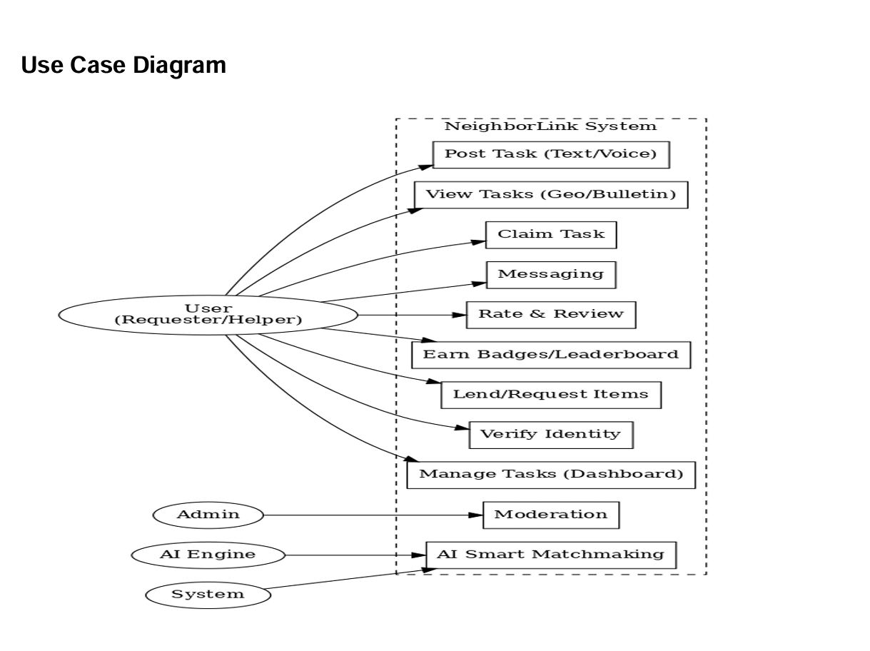

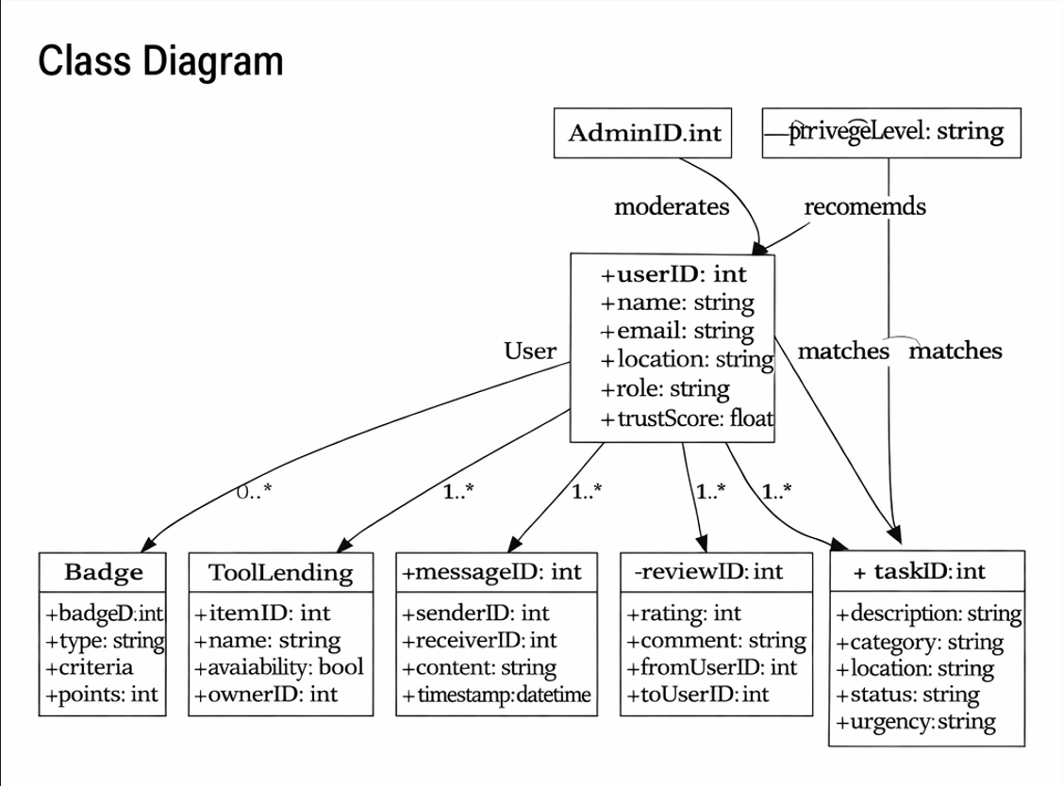

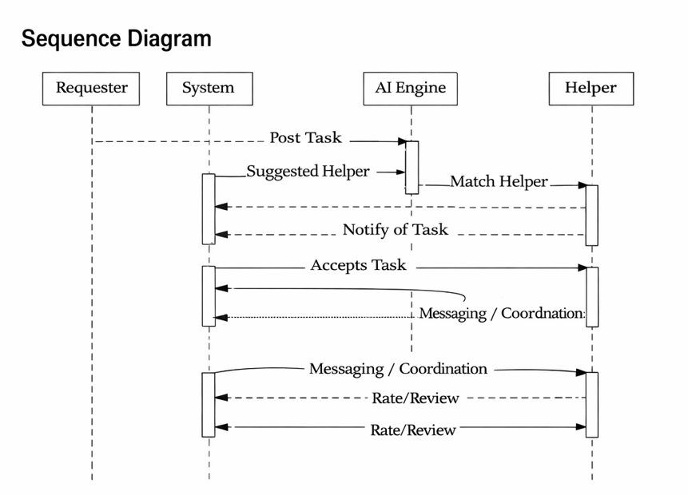
- Social Impact

NeighborLink promotes stronger community relationships by encouraging cooperation and mutual assistance among neighbors. The platform helps elderly individuals and people with limited mobility receive timely support while allowing students and volunteers to contribute meaningfully to their communities.
By reducing dependency on expensive services for minor tasks, NeighborLink supports cost-effective living and fosters a culture of kindness, trust, and social responsibility. The system also encourages sustainable practices through eco-friendly task incentives, contributing positively to society.

- Development Plan with Project Schedule

In your document you should provide a proper development plan that presents in every SDLC including project schedule. To prepare project schedule use any project management tools. Don’t make the schedule in MS word/ excel.

Project Planning
This phase focused on defining the project scope, objectives, and feasibility. Team roles and responsibilities were assigned, potential risks were identified, and an overall project timeline was prepared. The planning phase ensured a clear understanding of project goals and resource allocation before proceeding to development activities.

Requirement Gathering and Analysis
In this phase, detailed functional and non-functional requirements were collected through problem analysis and stakeholder consideration. The requirements were documented in the Software Requirements Specification (SRS), ensuring clarity and completeness. This phase helped establish a strong foundation for system design and development.

System Design
The system design phase translated requirements into technical solutions. UML diagrams such as use case, class, sequence, and activity diagrams were designed to represent the system’s structure and behavior. Database design and interface planning were also carried out to ensure system scalability and usability.

Development
During the development phase, the system was implemented based on the approved design. Frontend and backend components were developed in parallel, and core features such as task posting, messaging, AI-based matching, and user management were integrated. Continuous coordination among team members ensured consistency and progress.

Testing
Testing was performed to verify system functionality and reliability. Unit testing, integration testing, and user acceptance testing were conducted to identify and fix defects. This phase ensured that the system met all specified requirements and provided a stable user experience.

Deployment
After successful testing, the system was deployed to a live environment. Deployment activities included server setup, configuration, and final verification. This phase ensured that the system was accessible and operational for end users.

Maintenance
The maintenance phase focuses on post-deployment support. It includes monitoring system performance, fixing bugs, applying updates, and incorporating user feedback to improve system quality and usability over time.

Project Schedule Using Trello
The project schedule was prepared using Trello, where each SDLC phase was represented as a separate list, and individual tasks were created as cards within those lists. Tasks were assigned to team members with defined timelines and progress tracking. This approach allowed efficient monitoring of project activities, ensured accountability, and supported timely completion of the project.

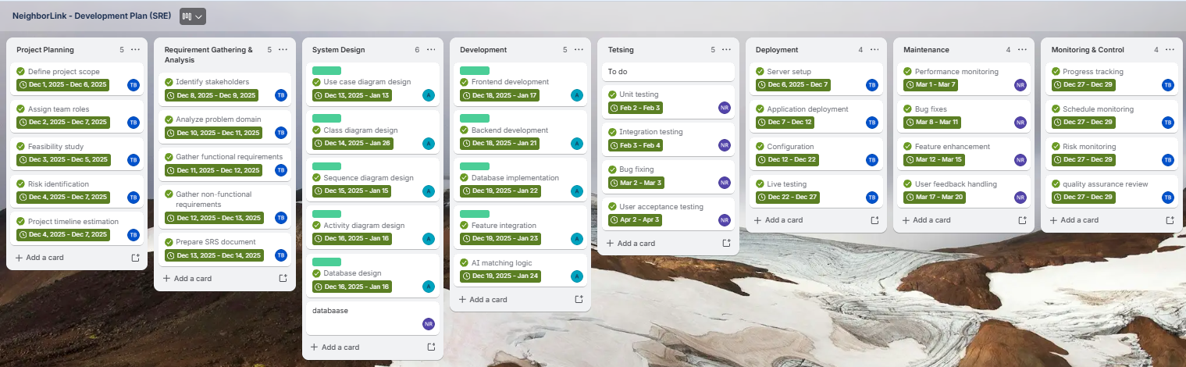

- Marketing Plan
The success of NeighborLink depends on building trust and adoption within local communities. The marketing strategy is designed to gradually introduce the platform, expand its reach, and maintain long-term engagement.

Short-Term Marketing Plan
In the initial phase, the focus will be on awareness and early user acquisition. NeighborLink will be promoted through university campuses, residential communities, and social media platforms such as Facebook and Instagram. Early adopters will be encouraged through referral rewards, volunteer badges, and free access to premium features for a limited time. Demo sessions and pilot testing in selected neighborhoods will help gather feedback and build credibility.

Long-Term Marketing Plan
For long-term growth, NeighborLink will partner with local NGOs, community organizations, and city corporations to promote volunteering and neighborhood cooperation. The platform can also collaborate with housing societies and apartment managements to onboard residents in bulk. As user adoption increases, the system will expand to new geographic areas and introduce advanced premium features for sustained revenue generation.

Continuous Marketing Plan
Continuous marketing efforts will focus on user retention and engagement. Regular feature updates, seasonal community events, leaderboard highlights, and success stories will be shared through newsletters and social media. User feedback will be actively collected and incorporated to improve the platform and maintain long-term trust within the community.

Cost and Profit Analysis
Cost Analysis
The estimated costs for developing and operating NeighborLink are outlined below:
- Development Cost:
The project is developed by a three-member team. Considering development time, design, testing, and documentation, the estimated development cost is moderate and suitable for a startup-level project.
- Infrastructure Cost:
Includes web hosting, cloud server services, database management, and security services.
- Marketing Cost:
Initial marketing through social media promotions, community outreach programs, and branding activities.
- Maintenance Cost:
Ongoing costs for bug fixing, feature updates, performance optimization, and customer support.
Overall, the cost structure is scalable, allowing expenses to grow gradually as the user base increases.

Profit Analysis
NeighborLink has multiple revenue-generating opportunities, making it attractive to potential investors:
- Premium Subscription Model:
Users can access advanced features such as task prioritization, analytics, and extended task management through a monthly or yearly subscription.
- Commission-Based Transactions:
A small service commission can be applied to paid or escrow-based tasks.
- Partnerships and Sponsorships:
NGOs, local businesses, and sustainability partners can sponsor community campaigns and events through the platform.
- Advertising Opportunities:
Local businesses can promote their services to nearby users in a controlled and relevant manner.
Based on these revenue streams, NeighborLink has strong potential for sustainable profit growth while maintaining its community-focused mission.

